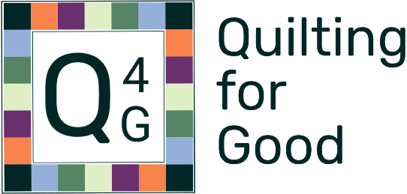

**Be a helper!**

Quilting for Good, a growing local effort, is looking for helpers! In 2023 we created over 80 quilts for women (and their children) living in transitional housing after graduating from Philadelphia’s emergency shelter for battered women and for a shelter for temporarily unhoused Philadelphia families.

Ways to be involved:

* Longarming. At this time, we’re particularly in need of long-arm services. It would be wonderful if you would volunteer to long-arm one or two quilts a month!
  + We’ll provide a quilt kit – top, batting, and backing. (Most are twin size; some larger, a few smaller.) You provide thread and your long-arm skills.
* Create quilt tops. Include backing and binding fabric if you’d like. We’ll add batting. Twin size preferred.

Contact Susan at [sorenson2007@gmail.com](mailto:sorenson2007@gmail.com) or 215.900-3454 with questions and/or to arrange for kit delivery. Keep up to date via the [Quilting for Good Facebook page](https://www.facebook.com/profile.php?id=61562095653492).

Thank you for helping someone keep warm!